Sheffield Steady Tunes- commonly played tunes that the hosts can start if requested.
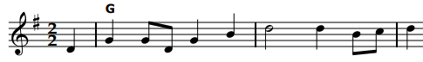

1. Appelbo Ganglat
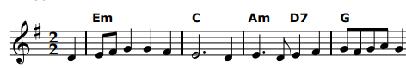

2. Bagpipers
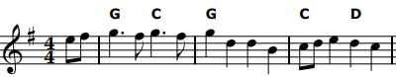

3. Bonnie Kate
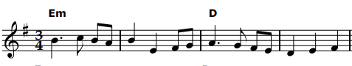

4. Bonny at Morn
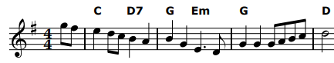

5.Brighton camp
(the girl I left behind)
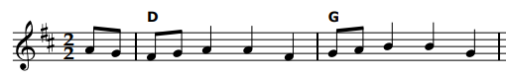
6. Buttered peas
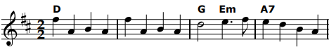

7. Egan’s Polka
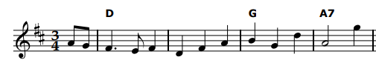

8. Elsey’s Waltz
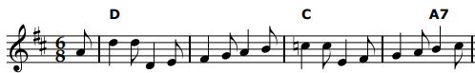

9. Fiery Clockface
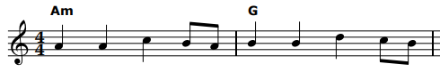

10. Goddesses

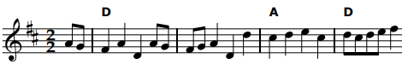

11. Harper's Frolic

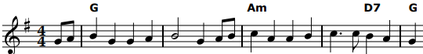

12. Jimmy Allen
.

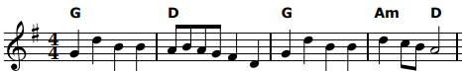

13. Mount Hills
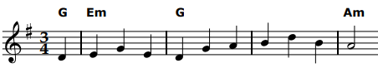

14. Orange in Bloom
(Sherborne Waltz)

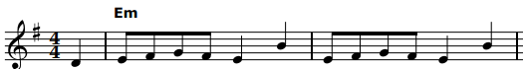
15. Rochdale Coconut
Dance

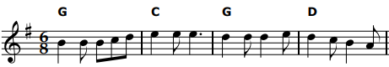

16. Rogue’s March

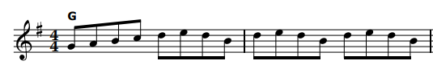

17. Speed
the plough

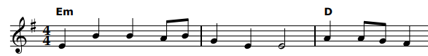

18. Theme
Vannetaise

19. Winster Gallop
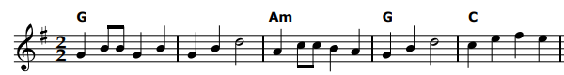

Extracts from Paul Hardy’s session tunebook. You can find and download the full score at pghardy.net

